Lab 1: Basic Techniques
We start with a lab to meet many of the tools that we shall be using through the course. As with all the labs in this course, the writeup is the answers that yo type into the boxes in the lab along with pictures and graphs that you paste into them. Lab writeups are always due at the start of the following lab and are to be submitted directly on Blackboard.

This year each of you will have your own workstation which be your assigned spot for the entire semester. You will time-share this with someone in the other section and sometimes with people in Musical Sound, however, and thus are responsible for leaving the workstation tidy at the end of each lab. You will each have your own breadboard and may leave stuff set up on the breadboard and put the breadboard up on the shelves at the end of lab, though any components that we have in limited quantities might be needed by the other section and get borrowed.

Part 1: A DC Circuit

Start by building the little circuit shown on the left of the figure below on your breadboard. If you have the other style of breadboard then you will have to be slightly flexible. You will find the resistors that you need in one of the blue drawers. They are large white brick shaped objects with leads coming out of each end. One will be marked (among other things) 270R and the other 100R or 100Ω. Try to make the circuit look as much as possible like the picture to the right of the diagram It has been arranged so that the positions of the actual resistors match closely with the way they appear in the diagram. You will need a wire from ground to the bottom row of a power contact strip. Then the 100R resistor (Resistor 1) goes from another hole in that row to a hole somewhere on the body of the breadboard. The 270R resistor (Resistor 2) goes from another hole in that same column up to the top power row, and a wire goes from that top row to +5V. When you have built this check with me before turning on your board.

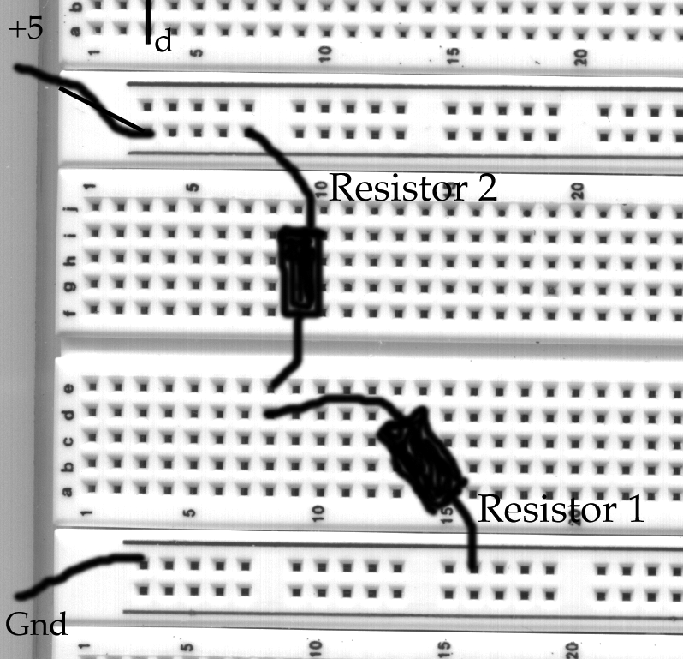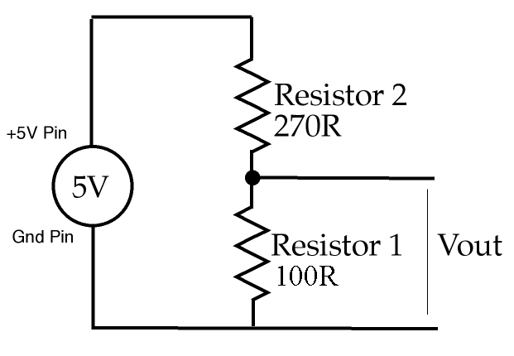

a) Measuring with the DMM
According to Ohm’s law, the voltage across a resistor is proportional to the current through the resistor. Mathematically, V=IxR, where V is the voltage (potential difference) in Volts, I is the current in Amps, and R the resistance in Ohms.
Assuming that we can measure the voltage without stealing any current from the circuit (a very good assumption) this implies that the voltage across R2 should be 2.7 times the voltage across R1.
Measure the two voltages with a Digital Multimeter (DMM), list your results below and discuss whether they confirm or deny the prediction.
R2: 3.64 V
R1: 1.33 V
This confirms the prediction, since 3.64 / 1.33 = 2.737

Now measure the current flowing in the resistors using your Digital Multimeter and check that you still have agreement with Ohm’s law.
BEWARE: In order to be measured, the current must flow through the meter. You will have to break circuit loop and insert the meter.
13.1 mA

b) Measuring with the Oscilloscope
Repeat the voltage measurements in your circuit using your oscilloscope instead of the digital multi-meter and compare your results.
Connect a scope probe to the CH.1 input of your scope. Select the DC coupling option in the channel menu. Measure the voltage across resistor R1 in the circuit on the left with the scope, varying the VOLT/DIV scale to get a precise reading.
Note that you must connect up both parts of the scope probe; the ground clip and the measuring hook.
R1: 1.35 V
R2: 5.04 V - 1.35 V = 3.69 V

Oscilloscopes have a peculiarity. Their ground wires are connected to mains ground and thus the ground of channel 1 is connected internally to the ground of channel 2. Thus, you CANNOT measure two unrelated voltage drops with a scope--the ground clips must always go to the same place. There is more. The power supplies that we use also connect their black terminals to mains ground and so connect them to the oscilloscope’s ground. Thus, you MUST ALWAYS connect the ground clips of the scope to the ground point of the power supplies and make all measurement with respect to ground.
For example, you cannot measure the voltage across resistor R2 directly. Instead, you must measure the voltage at one end relative to ground and then measure the voltage at the other end relative to ground and subtract the two voltages to get the voltage across R2.
What do you get if you ignore this and try to measure the voltage across R2 directly? Is this value correct?
The screen reads 5.04 V. This value is not correct; it’s the voltage drop over the whole circuit, not the voltage drop across R2. This is because the ground clip on the oscilloscope is connected to the outlet’s ground.

Part 2: An AC Circuit
Disconnect the wire going to the +5 V power supply and reconnect it to one of the BNC connectors on the right side of your workstation. You may need to replace the wire with a longer one.

Connect the sine wave output (labelled Output 50Ω) of your Instek function generator to the BNC connector with one of the BNC cables.

Connect a scope probe from CH1 of you scope to the upper end of R1 and to ground. Make sure the scope is set to trigger on CH1 and set the VOLTS/DIV to 0.5 V/div.

Set the function generator to produce sine waves at 200 Hz and adjust the function generator’s AMPLITUDE knob until you get a 2 V P-P signal on the scope. Notice how the appearance of the trace changes as you vary the VOLTS/DIV and TIME/DIV scales on your oscilloscope.

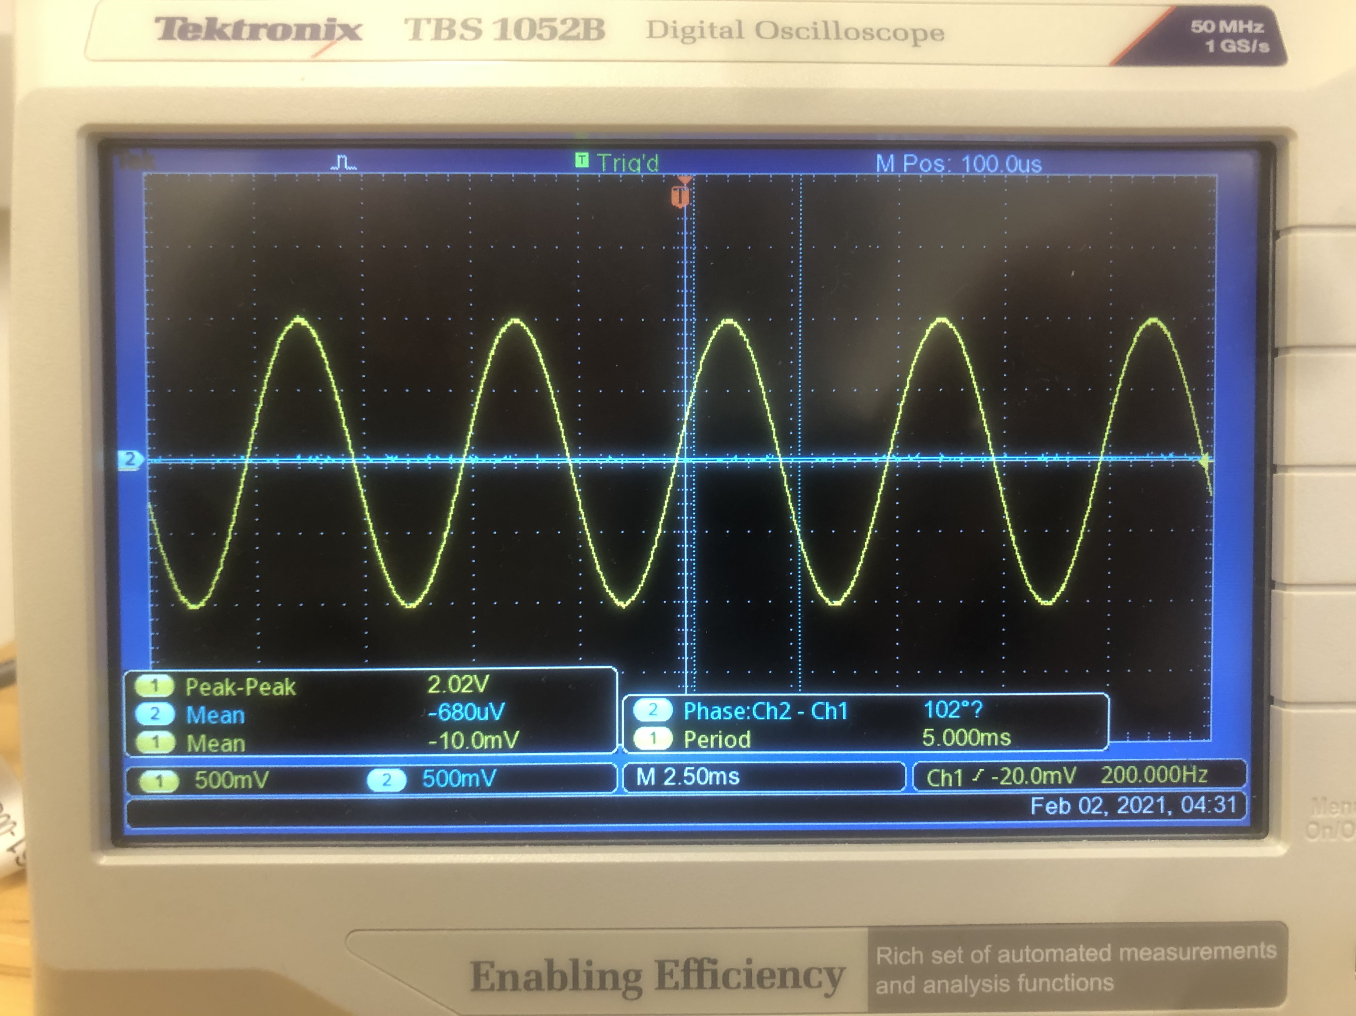
Adjust the Time/Div setting on your scope to display several periods, take a picture of the screen and paste it below.

Use the Cursor function to measure the period T of the cycles on the scope, and verify that the frequency f is given by f=1/T.
The frequency is 200 Hz, and the period is 5.02 ms. This makes sense, since 1/(200 Hz) = .005 s = 5 ms.

Use a digital multimeter (DMM) on its AC setting to measure the sine wave voltage output of the signal generator.
Compare the DMM readings (which are r.m.s. or “effective” voltages with the peak-to-peak voltages read off the scope screen. Are they consistent? (Remember the amplitude of a signal is one-half the peak-to-peak voltage!
The DMM reads 0.4 V, and the oscilloscope reads 2.02 V peak-to-peak. I think the DMM reading is not useful.

Part 3: Introduction to Eagle
Use the simulation features of Eagle build a model of the simple voltage divider circuit shown in the adjacent figure. Run an Operating Point simulation and paste a screenshot of your result below.

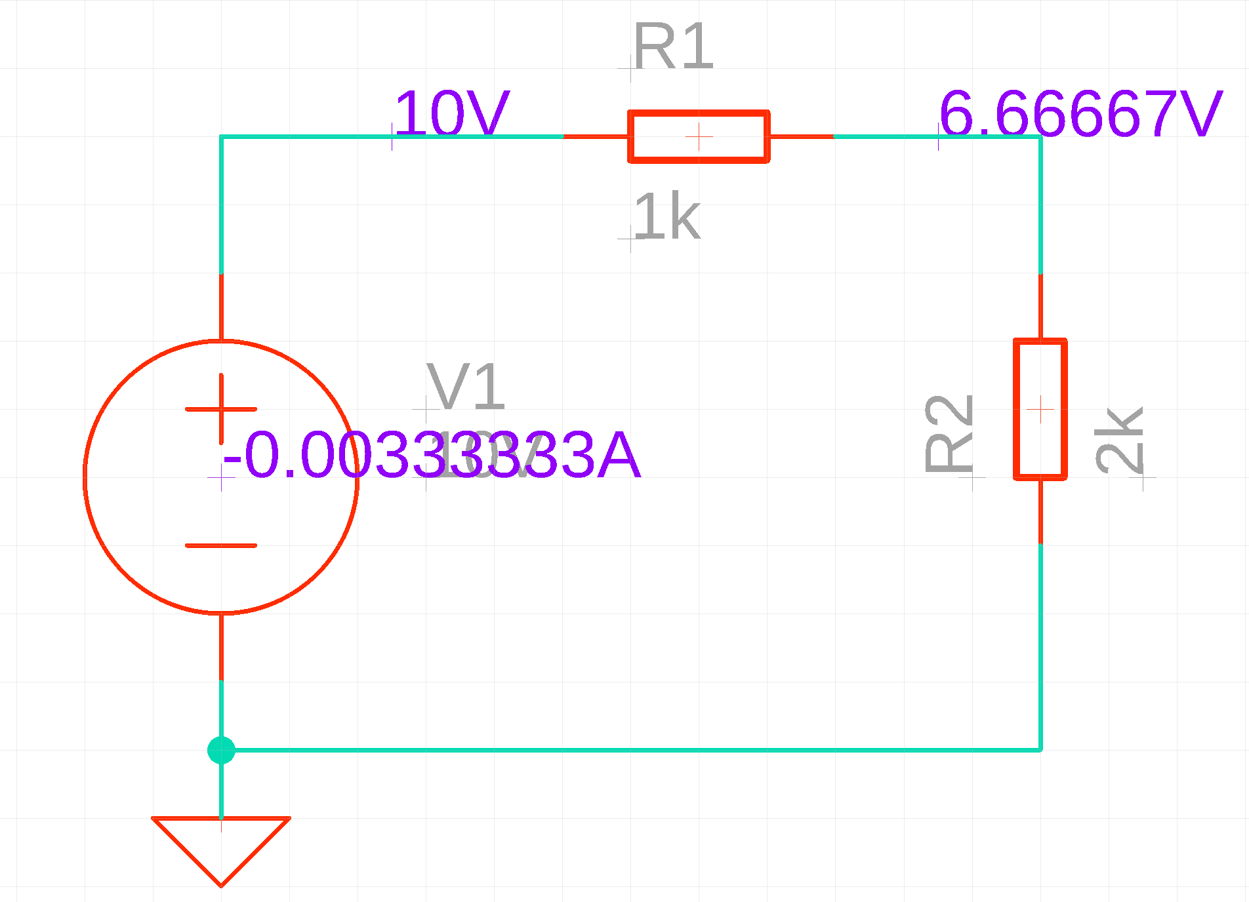

Give the voltage at the output and explain its value using Ohm's law.
The voltage at the output is 6.666V. According to Ohm’s law, since the total resistance in the circuit is 3k Ohms, the current in the circuit is .00333A. Since R1’s resistance is one third of the total resistance of the circuit, Ohm’s law suggests that we would see a voltage drop of 3.333 volts across R1.

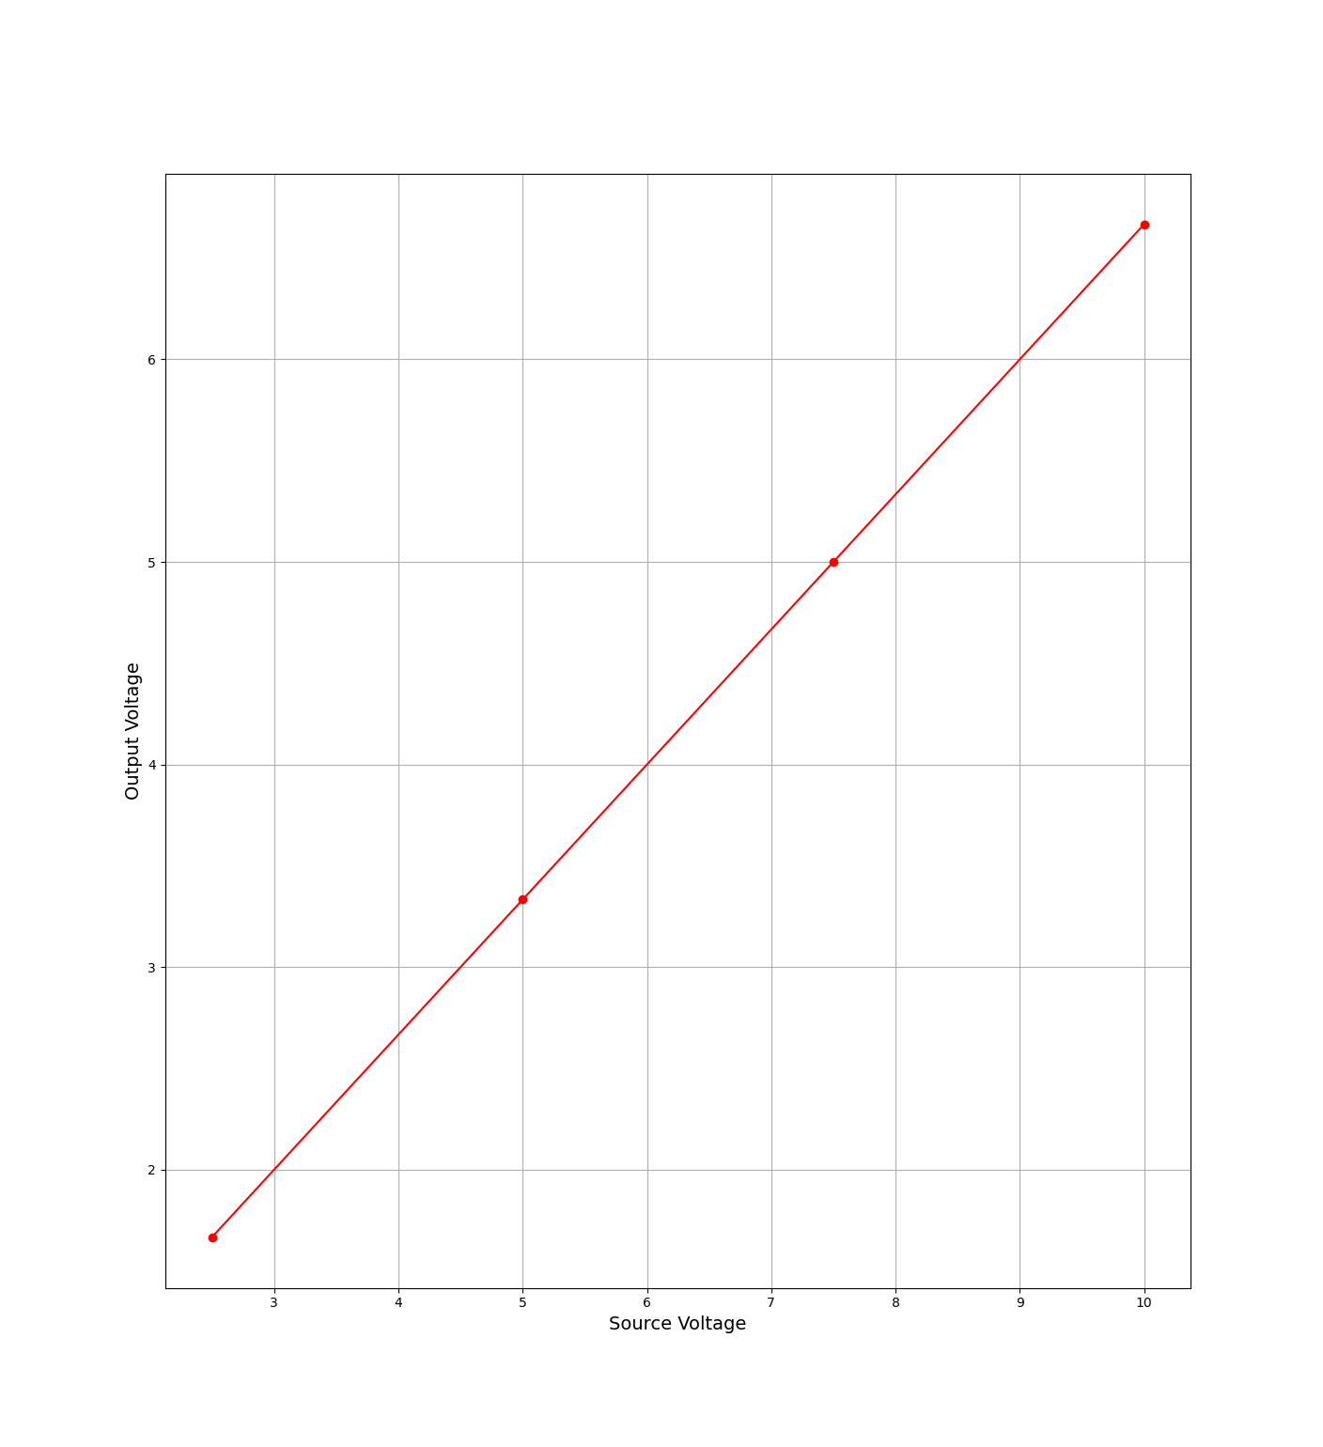
Repeat the experiment for several different values of the voltage source between 0V and 10V, recording the output voltage at each point. Using Excel or another tool of your choice, plot Vout as a function of Vin, the power supply voltage, and paste a properly laballed graph below.

Discuss whether, and if so how, your result suggests that this would be called a linear circuit.
My result suggests that the circuit is a linear circuit, since there is a linear relationship between the source voltage and the output voltage.

